Are you a farmers market wanting to find new customers for the farmers and support for the market? Are you interested in expanding your market to accept SNAP and other federal benefit programs? Does your market currently have or are you planning to install EBT machines and are looking to expand participation?

Florida Organic Growers (FOG) received a Specialty Crop Block Grant from the Florida Department of Agriculture and Consumer Services to increase sales of Florida grown fruits and vegetables to Florida consumers. This grant increases access to and consumption of healthy, locally produced fruits and vegetables for low-income Florida residents through an incentive program at Farmers Markets for the Supplemental Nutrition Assistance Program (SNAP-formerly known as food stamps).
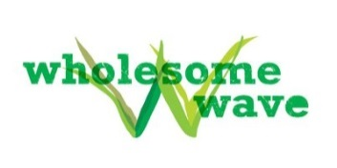
The proposed project builds a highly visible network of Florida farmers markets implementing innovative programs that incentivize the use of federal nutrition assistance benefits to purchase fruits and vegetables. To increase the demand for locally grown fruits and vegetables in underserved communities, FOG works with Wholesome Wave (WW), a national leader in the implementation of nutrition incentive programs.

FOG provides training and technical assistance (TA) to farmers market staff in order to facilitate their ability to efficiently redeem federal nutrition assistance benefits, such as SNAP. Assistance includes trainings on the use of Electronic Benefits Transfer (EBT) machines (needed to redeem SNAP benefits) as necessary. As part of this TA, we facilitate Florida markets’ and farmers’ access to new USDA funding that covers the cost of the EBT machine and wireless access for two years.

In partnership with WW, FOG also provides training and technical assistance, materials and initial incentive funding to implement our incentive program called Fresh Access Bucks. FOG will partner with at least 20 markets throughout the state over the two years. The incentive program, now being implemented by WW at more than 300 markets with almost 60 partners across the country, doubles the value of federal nutrition assistance benefits (including SNAP, WIC and Senior FMNP) redeemed at farmers markets. For example, an individual spending $10 at a participating market can buy $20 worth of fruits and vegetables-- doubling revenues for specialty crop farmers and making healthy, fresh fruits and vegetables much more affordable for low-income Florida residents.

To promote long-term sustainability, FOG works closely with local farmers markets and are expected to provide staffing for the EBT and incentive programs, assist in outreach, provide supplies for the EBT and incentive booth, including a tent, tables, chairs, etc., (matching funds may be available to assist with these supply costs), collect and enter data, and have the capacity to administer the additional accounting required from this program.

For more information, contact Carmen Franz at carmen@foginfo.org or (904) 624 -1532.

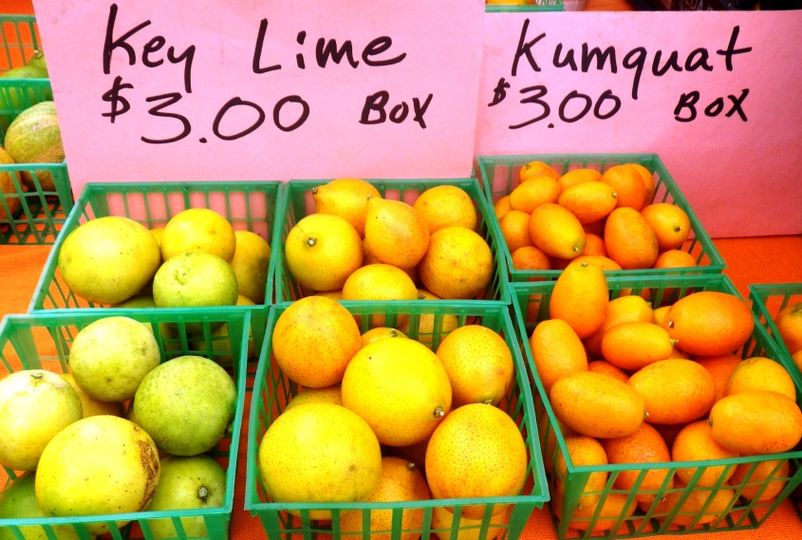
Name of Farmers Market: ___________________________________________________________________________

Market Manager(s):________________________________________________________________________________

Phone Number: ___________________________________________________________________________________

Location/Address: _________________________________________________________________________________

County: __________________________________________________________________________________________

Market Start Date: ________________________________

Market End Date: ________________________________

Day/time of Market: _______________________________

Number of Vendors: _____________

Number of Farmers: _____________

Number of farmers who are selling Florida grown fruits and vegetables: _______________________

Does this market accept credit/debit cards? Yes No

Does this market accept EBT? Yes No
- Does this market have a centralized system for EBT transactions? Yes No
- Who administers the EBT program on site at the market (a market manager, a volunteer, student/intern, vendor)? ___________________________________________________

Has this site accepted federal benefits or implemented a DVCP program before? Yes No

Tell us about your community.

What are the opportunities/challenges of your farmers market?

Have you talked with consumers and farmers about the potential of accepting SNAP, other federal benefits, and/or an incentive program? If so, what is their feedback?

What challenges do you foresee in implementing the EBT or DVCP at this farmers market, or within this community?

Would this market be able to provide matching funds/in kind to support this program (including staffing needs, promotion, data collection, and some materials such as a tent, table, etc.)?

