Are you a farmers market, CSA or Mobile Market wanting to find new customers for the farmers and support for the market? Are you interested in expanding your market to accept SNAP and other federal benefit programs? Does your market currently have or are you planning to install EBT machines, and are looking to expand participation?

Florida Organic Growers (FOG) received a Specialty Crop Block Grant from the Florida Department of Agriculture and Consumer Services to increase sales of Florida grown fruits and vegetables to Florida consumers. This grant increases access to and consumption of healthy, locally produced fruits and vegetables for low-income Florida residents through a nutrition incentive program called Fresh Access Bucks at Farmers Markets, CSAs (Community Supported Agriculture Shares) and Mobile Markets for Supplemental Nutrition Assistance Program (SNAP) recipients (formerly known as food stamps).

The program builds a highly visible network of Florida farmers markets implementing innovative programs that incentivize the use of SNAP benefits to purchase fresh fruits and vegetables directly from Florida farmers. To increase the demand for locally grown fruits and vegetables in underserved communities, FOG works with Wholesome Wave (WW), a national leader in the implementation of nutrition incentive programs.

FOG provides training and technical assistance (TA) to farmers market staff in order to facilitate their ability to efficiently redeem federal nutrition assistance benefits, such as SNAP. Assistance includes trainings on the use of Electronic Benefits Transfer (EBT) machines (needed to redeem SNAP benefits) as necessary. As part of this TA, we facilitate Florida markets’ and farmers’ access to new USDA funding that covers the cost of the EBT machine and wireless access for three years.

In partnership with WW, FOG also provides training and technical assistance, materials and initial incentive funding to implement our nutrition incentive program called Fresh Access Bucks. FOG currently has 26 participating farmers markets and 2 CSAs statewide. The incentive program, now being implemented by WW at more than 300 markets with almost 60 partners across the country, doubles the value of SNAP benefits redeemed at farmers markets. For example, an individual spending $20 of their benefits receives an additional $10 to purchase more fresh, local produce -- doubling revenues for specialty crop farmers and making healthy, fresh fruits and vegetables much more affordable for low-income Florida residents.

To promote long-term sustainability, FOG works closely with local farmers markets that provide staffing for the EBT and incentive programs, assist in outreach, provide supplies for the EBT and incentive booth, including a tent, tables, chairs, etc., (matching funds may be available to assist with these supply costs), collect and enter data, and have the capacity to administer the additional accounting required for this program.

For more information, contact FOG’s FABulous team at info@FreshAccessBucks.com or (352) 377-6355, ext.125.

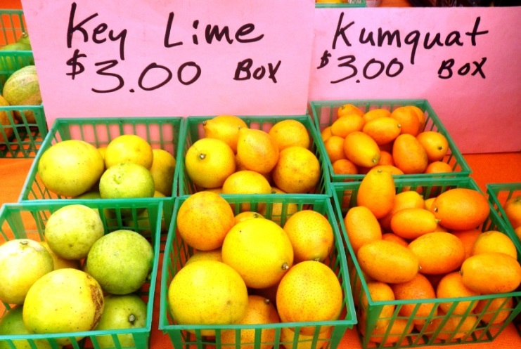

Name of Farmers Market: ___________________________________________________________________________

Market Manager(s):________________________________________________________________________________

Organization/Entity that Manages the Market (i.e. LLC, corporation, 501c3, 501c4, 501c5, for-profit entity, etc.):

_________________________________________________________________________________________________

Phone Number: ______________________________________Email: ________________________________________

Location/Address: __________________________________________________________________________________

County: __________________________________________________________________________________________

Is your market open year round? ______
If no, what is your Market Start Date: ________________________and Market End Date: _________________________

Day(s)/time(s) of Market: ____________________________________________________________________________

Number of Vendors: _____________ Number of Farmers: _____________

Number of farmers who are selling Florida grown fruits and vegetables: _______________________

Does this market accept credit/debit cards? Yes No

Does this market accept EBT? Yes No

- Does this market have a centralized system for EBT transactions? Yes No

- Who administers the EBT program on site at the market (a market manager, a volunteer, student/intern, vendor)? _______________________________________________________________________________

Has this site accepted federal benefits or implemented an incentive program before? Yes No

Does this market organize nutrition education initiatives? (i.e. cooking demos, distribute recipe/nutrition cards) Yes No

Tell us about your community.

What are the opportunities/challenges of your farmers market?

Have you talked with consumers and farmers about the potential of accepting SNAP, other federal benefits, and/or a Nutrition Incentive Program? If so, what is their feedback?

What challenges do you foresee in implementing EBT and the Nutrition Incentive Program at this farmers market, or within this community?

Would this market be able to provide matching funds/in kind to support this program (including staffing needs, promotion, data collection, and some materials such as a tent, table, etc.)?

What local entities/organizations actively support and/or work with your market in some capacity? (i.e. nonprofits, county Health Department, government, community groups, etc.)

What types of outreach efforts does the market do to advertise for itself and its vendors?

